📽️ Automated Creative Analysis Pipeline
Google Drive → Gemini 2.0 Flash → ChatGPT → Notion

1. Project Overview
This project is a fully automated creative analysis and content structuring pipeline designed to transform raw marketing videos into structured, reusable, and production-ready creative frameworks stored in Notion.
The system continuously monitors a Google Drive folder for newly uploaded videos. When a new video is detected, the workflow automatically:
- Downloads the video file
- Sends the video to Gemini 2.0 Flash for structured creative analysis
- Passes the structured output to ChatGPT for strict linguistic adaptation and formatting
- Converts the result into a Notion-compatible format
- Creates a dedicated Notion page
- Sets a dynamic page title
- Inserts a structured creative table inside the page
- Embeds the original video directly inside the same page
This design ensures that every creative analysis exists as a self-contained Notion page, combining both the framework and the original source video in one location.

2. Problem Statement
Marketing and creative teams often analyze high-performing video creatives manually to extract:
- Hooks
- Emotional beats
- Product reveals
- Proof points
- Calls-to-action
This process is:
- Time-consuming
- Inconsistent
- Difficult to scale
The goal of this project is to automate the creative analysis process end-to-end while ensuring:
- Structural consistency
- Strict sentence-level language mapping
- Visual and audio documentation
- Direct storage in a production-ready system (Notion)

3. High-Level Architecture
Google Drive
↓
Google Drive Trigger (n8n)
↓
Download File Node
↓
Structured Agent (Gemini 2.0 Flash)
↓
Filling Placeholder Agent (ChatGPT)
↓
Code Node (JSON → Notion Format)
↓
Notion Page Creation Node
↓
Create Page Title Node
↓
Create Notion Table Node
↓
Embed Original Video Node

Workflow:

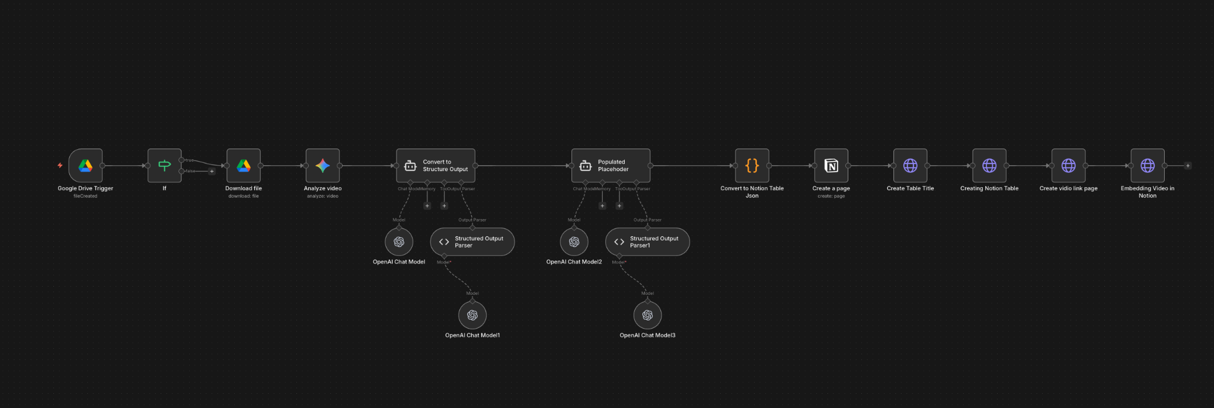

4. Core Technologies
Technology | Role
n8n | Workflow automation engine
Google Drive API | Video ingestion and trigger system
Gemini 2.0 Flash | Creative video analysis and structured table generation
ChatGPT | Linguistic adaptation and strict 1:1 script formatting
Notion API | Storage, visualization, and creative documentation
JavaScript (n8n Code Node) | JSON transformation and API payload formatting

5. Workflow Breakdown (Node-Level)

5.1 Google Drive Trigger
Purpose:
Monitors a specific Google Drive folder for new video uploads.
Behavior:
- Fires when a new file is added - Captures metadata such as file name, file ID, MIME type, and public web link
Output Example:
{
"fileId": "abc123",
"fileName": "ad_video.mp4",
"webViewLink": "https://drive.google.com/..."
}

5.2 Download File Node
Purpose:
Downloads the raw video file for AI processing.
Behavior:
- Fetches binary video data from Google Drive - Prepares the file for ingestion by the AI analysis agent

5.3 Structured Agent (Gemini 2.0 Flash)
Purpose:
Analyzes the full video and generates a structured creative framework table.
Design Goals: - Product-agnostic framework - Placeholder-based rewriting - Line-by-line script breakdown - Full visual and audio documentation
Output Schema:
Gemini generates a six-column table:
Column | Description
Framework Section | Hook, Conflict, Solution, Proof, CTA
Reference Script | Original spoken script (unaltered)
Script Breakdown | Universal placeholder-based rewrite
Visual Description | On-screen visuals and editing cues
Shot Type | Camera framing and angle
Audio | Voice, music, and sound design
Placeholder Logic:
All product- or niche-specific language is replaced with placeholders such as: - [problem] - [product] - [benefit]
This ensures that the creative framework can be reused across industries and campaigns.

5.4 Filling Placeholder Agent (ChatGPT)
Purpose:
Transforms Gemini’s structured output into a strictly formatted, production-ready table while preserving emotional pacing and sentence alignment.
Core Rules Enforced: - Exactly six columns - Strict 1:1 sentence adaptation - No added or removed phrases - Same emotional pacing - Same reading duration - Spoken Québec French style - Visual and audio alignment preserved
Product Context Applied:
Product: Linge à vaisselle Aloha
Primary Angle:
> Le linge à vaisselle qui enlève toute l’eau d’un seul coup — sans trace, sans odeur, et qui sèche rapidement.
Integrated Benefits: - Instant absorption - Fast drying - Odor resistance - Modern design - Quebec-inspired branding
Promotion Logic:
> Buy 2 → Get 2 Free
Promotional elements are injected only where structurally appropriate in the original script.

5.5 Code Node (JSON → Notion Formatter)
Purpose:
Converts the AI-generated structured output into a Notion API-compatible payload.
Responsibilities: - Parse structured AI output - Extract table rows and columns - Map values to Notion block schema - Prepare video embed block
Example Transformation:
Input:
{
"Framework Section": "Hook",
"Script Ref": "I can't believe this worked",
"Script Breakdown": "J’peux pas croire que ça a marché",
"Visual": "Close-up reaction",
"Shot": "Talking head",
"Audio": "Natural voice"
}
Output (Notion Block):
{
"type": "table_row",
"cells": [
[{ "type": "text", "text": { "content": "Hook" }}],
[{ "type": "text", "text": { "content": "I can't believe this worked" }}],
[{ "type": "text", "text": { "content": "J’peux pas croire que ça a marché" }}],
[{ "type": "text", "text": { "content": "Close-up reaction" }}],
[{ "type": "text", "text": { "content": "Talking head" }}],
[{ "type": "text", "text": { "content": "Natural voice" }}]
]
}

5.6 Notion Page Creation Node
Purpose:
Creates a new parent page inside the target Notion workspace or database.
Behavior:
- Sends a request to the Notion API to create a blank page - Returns a unique page identifier
Output Example:
{
"page_id": "notion_page_123"
}
This page ID is used as the container for all downstream Notion operations.

5.7 Create Page Title Node
Purpose:
Applies a dynamic title to the newly created Notion page.
Behavior:
- Uses the returned page_id - Sets a title based on contextual metadata such as: - Video file name - Campaign name - Timestamp
Example:
> Creative Analysis – ad_video.mp4

5.8 Create Notion Table Node
Purpose:
Inserts the structured creative framework table into the titled page.
Behavior:
- Maps all six AI-generated columns into Notion table rows - Preserves row order and framework section grouping - Optionally attaches metadata fields such as: - Date - Product - Campaign - Language

5.9 Embed Original Video Node
Purpose:
Embeds the original Google Drive video directly inside the same Notion page for visual reference and creative validation.
Behavior:
- Uses the webViewLink from the Google Drive Trigger - Creates a Notion embed block - Positions the video above or below the structured table

6. Notion Output Structure
Each processed video generates a single structured page containing:
📄 Notion Page
📝 Page Title
📊 Structured Creative Table
🎥 Embedded Original Video
🏷️ Metadata (Date, Product, Campaign, Language)
This structure supports: - Filtering - Creative comparison - Framework reuse - Production handoff

